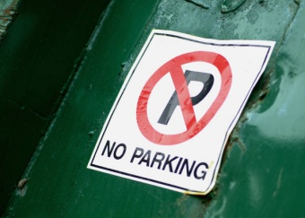
Please DO NOT in the Faith Community Church parking lot on Saturdays and also please DO NOT park in the grass behind the church and beside the playground!

Please use the Hopewell Schools parking lots or park along the access road . . . .

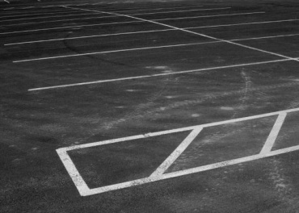

Please feel free to use the grass area off Barrett Road (near Fields 7 & 10) when the weather / ground is dry.

The Faith United Methodist parking lot is off-limits for general parking through the season. Head coaches and referees were given parking passes to place in the front window. Only cars with parking permits are permitted to park in the church or Hopewell concession stand lot.

If we cannot control this - the church will not allow us to use their lot in the future.

